**PROJECT CHAT**

|  |  |  |
| --- | --- | --- |
| **Criteria** |  | **Grade** |
| **Functionality** | **25%** |  |
| **Quality** | **25%** |  |
| **Originality** | **25%** |  |
| **Feasibility** | **25%** |  |
| **Total** | **100%** |  |

**Developers:**

**De Leon, Jobelle G.**

The System is about chat. What it can do is register a user, and let them chat to each other. But in the current state of the system. The chat functionality can only work in the local server but if we upload it on a hosting server it can do like what Facebook can do. Technologies today are upgrading too fast and the “real-time” are taking over the current technologies. Because real-time technologies helps many people to decide faster. Good example of real-time technology is what they use in weather forecast. The technology that they are using is real-time based technology to tell people whether they should evacuate or what action should they do.

The technologies we used is:

**PHP** – an open source programming language.

**Laravel Framework** – Laravel Framework is a MVC technology. MVC means Model View Controller. The process of an MVC framework is different than a normal process of a programming language. MVC Framework separates all the process of the system to reduce the process time it takes when a user makes an action. The Model makes all the process, View only displays the data to the user, and Controller is the one who tells the Model what function should be triggered based on the user’s action.

**PusherJS** – Pusher JS is a company that provides real-time feedbacks to the system. If the user makes an action a certain event will be triggered and it will pass a data to the Pusher JS and it will automatically updates the user.

**Sublime Text 3** – Sublime Text 3 is also like notepad++.

**Sequel Pro** – The Database we used in the system.

**XAMPP** – We used XAMPP to run a local webserver.

Limitation of the System:

* It can only send up to 200,000 messages per day and the maximum users is only 10. This the limitation for free subscription.
* It needs an internet connection to make the real-time functionality work.
* You cannot choose a specific user to chat.
* Needs to be uploaded on a hosting site to make it work on mobile device or other devices.

The Scope is:

* The System allows the user’s to chat to each other.
* Let the user to register an account.

The reason we decided to make a chat system is to explore and learn more about the real-time technology, how does the real-time work. And as in our current level of programming ability it is easy for us to follow the instructions on how to create this system.

This is login page.

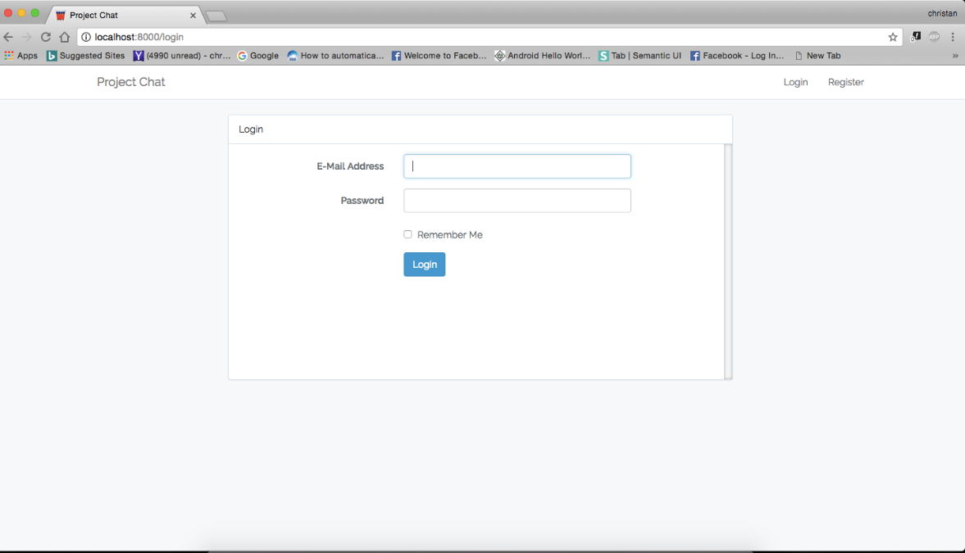

This is the Registration Page. The email must be unique. If the email you entered is already in the database it will throw a message error.

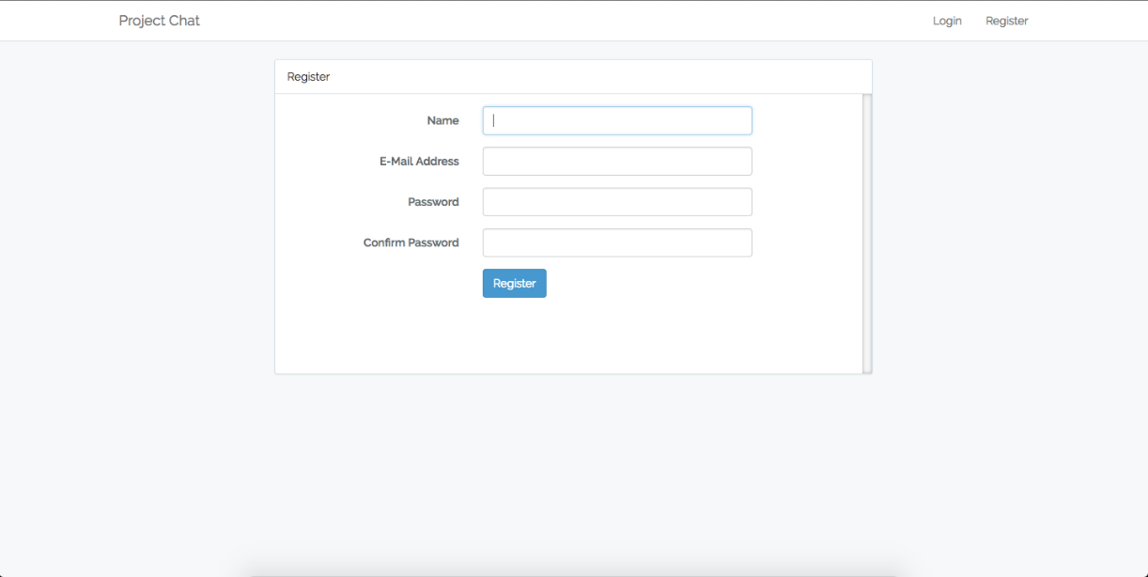

After you register to the system you will be automatically redirected to your dashboard.

